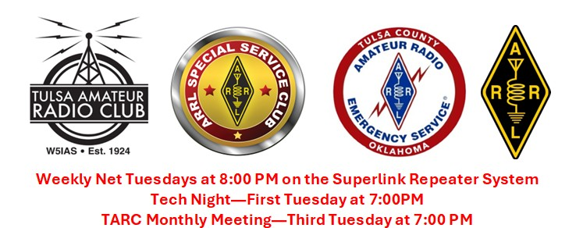
TARC Monthly Meeting Agenda – September 15, 2026

TARC Club Officers for 2026
President - Mark WA5MA
1st Vice President – Jack W5JHC
2nd Vice President Ky KY5VAR
Secretary – Andrew W5AWS
Treasurer - Jerry KE5PMK, Retiring in 2027
Public Service Liaisons - Bobby KJ5CLV, Vacant position
Repeater Trustee - Gregg W5GGW
Newsletter – Andrew W5AWS, Retiring in 2027
ARES Emergency Coordinator Tulsa County - Paul WB5ANX

Club Business
Approve July meeting minutes - Mark WA5MA
Approve July, August financials - Mark WA5MA
DamJam Bike ride wrap up - Paul WB5ANX
Maker Fair wrap up – Linda KI5VYF
Astronaut video
Satellite Station Go Box Approval – Mark WA5MA
Notification of upcoming elections for retiring TARC Officers – Mark WA5MA
New Divisions – Information Technology Service Unit, Antenna Installation Team (HamRescue)
Satellite Division - Looking for a satellite team to build a satellite station go box!
Do we want to continue the newsletter??? Online newsletter???

Upcoming meetings and events…
Route 66 on the Air 9/12 thru 9/20 – Daryl N5NYT
Fox Hunt 9/26 – John K1RFG
Simulated Emergency Test – 10/3
TARC Tech Night – 10/6, AI as a diagnostic tool, Andrew W5AWS
POTA Day – 10/17, Tony KA5TRO
TARC Monthly Meeting – 10/20

Adjourn – Be safe, Be a good friend, Get on the air!
Mark WA5MA
President – Tulsa Amateur Radio Club

