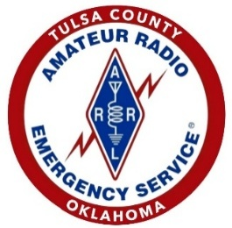
ARES Tulsa County
24 Hour Comms Go Bag Checklist

Communications Go bog
- Dual band handheld radio and speaker/mic (with spare battery & charger)
- Dual band Mobile/Base unit
- Magnetic mount antenna and/or roll up type antenna with paracord support
- Coax: RG-58/U (at least 25 feet)
- Connectors and adapters: PL-259/SO-239 TO BNC, PL-259/SO-239 to SMA (male and female), N, barrel connectors, etc.
- Extended gain antenna for HT
- Electrical tape and duct tape
- Small tool kit; larger tool kit in car
- Spare AA and AAA batteries
- ARES or TARC Shirt, ID (copy of Amateur license), Hi Visibility Vest, OKMRC ID
- Water bottle (2 quarts)
- Snacks: Granola bars, Power Bars, trail mix
- Sun Screen, Chapstick, Bug Spray, poison ivy medicine
- First-aid kit (Motrin, Imodium, Dramamine, Tylenol, Benadryl, earplugs, whistle)
- Prescription medications
- Toilet paper in a Ziploc bag (compress the air out), Kleenex
- Towel (small)
- Pocket knife (multifunction)
- Flashlights, light for brim of ball cap
- Digital Camera or camera on your phone
- Pens, pencils, markers, note pad
- Repeater directory (optional)
- Maps of Tulsa and Oklahoma (AAA area or Thomas Guides)
- Wicked Weather gear - Ski hat and gloves, leather gloves with liners, rain poncho, collapsible umbrella, ball cap, dry socks
- Space blanket
- Waterproof matches, butane lighters
- Paracord (two 50-foot lengths)
- Garbage bags (two 55 gallon, four large ziplock)
- AM/FM radio with batteries
- Four Cyalume light sticks (12-hour, green)
- Dust mask and wind goggles
- Batteries for personal devices (hearing aids, etc)
- Pepper spray (personal defense)
- Narcan
- NIFOG/OKFOG (Field Operating Guides)
- Deck of cards (markers, communications tool, fire starter, morale booster)
Optional
- IPAD or tablet PC with chargers
- ICS / NTS forms kit (including a copy of your FCC license)
- Charged power bank with appropriate cables

